THE PERCEPTION OF PONOROGO MUSLIM SOCIETY IN CHOOSING
ISLAMIC BANKING SERVICES

Naning Kristiyana¹, Adi Santoso²
Fakultas Ekonomi Universitas Muhammadiyah Ponorogo
Email; adisantoso@umpo.ac.id, No. Hp 082234441600
Abstract
Research on the perception of Ponorogo Muslim society in choosing Islamic banking services aims to know their perception toward Islamic bank and to determine the financial transaction done by them. This research was conducted in Ponorogo using quantitative descriptive research method. The population is lecturers of STAIN and FAI UNMUH Ponorogo. The sample of the research is 75 respondents. Primary data were collected using questionnaire. Analysis of the data in the field done by using descriptive quantitative format.Perception of both lecturers of STAIN Ponorogo and Islamic Faculty of UNMUH Ponorogo toward Islamic bank is good. It can be seen from the behavior of the consumers / respondents which was influenced by the factor of education in which it is majority dominated bypostgraduate level, culture factor through Islamic culture in work environment both in STAIN and UNMUH Ponorogo, as well as the stimulus of knowing Islamic products that generate the perception as a feedback of the stimulus. Financial transactions carried out by most of the respondents, or 63% of respondents use the services of conventional banks and Sharia banks, while those who use only pure Islamic financial services are just 11 respondents from the whole number of respondents. This has become a new phenomenon found in this study and the respondents use the services of conventional and Sharia banks are based on the rules of the institution where they work.
Keywords: Perception, Education, Culture, Sharia Bank

- INTRODUCTION

Banking financial institution has a strategic function as an intermediary institution and provides services in payment flows. This financial intermediation gives the fundamental role in the process of transfer of funds, so it can boost the economy. The process of transferring these funds is the process of buying surplus funds from both the economic unit of the government business sector and households’, in order to be channeled to deficit economic units. In addition, bank also has a very important role because as an institution which is capable of influencing economic activity through bank's ability to increase or decrease the purchasing potency in the economy.
Banking activities can be divided into two; conventional and Sharia banks. The provision of Sharia banking system is generally regulated in the Law 10 of 1998 where commercial bank is a bank conducting conventional business and or based on Sharia principles in its activities of providing services in the flows of payments. While the society financial and credit loansbank is a bank conducting business conventionally or based on Sharia principles which does not provide payment services in their actions.
Sharia banks have a same role with conventional banks although it has its own character, but they both are expected to complete one another and to provide services to people who have not been willing to utilize the services of conventional banks as well as to mobilize public funds which have not yet served by conventional banking system. The meaning of Sharia banks (Siamat, 2004: 183) in general is a bank that performs its business enterprises based on the principles of Islamic Sharia law referring to the Qur'an and Al Hadith. While the Sharia principles in accordance with Act No. 10 of 1998 is the treaty rules based on Islamic law between the bank and other parties to save money and or finance business activities or other activities stated agreeable with Sharia, such as financing based on the principle of profit sharing (Mudharabah), financing based on the principle of equity (Musharakah), the principle of buying and selling goods (Murabaha) or the financing of capital goods founded on the principle of pure lease (Ijara) or an option to transfer the ownership of goods leased from the bank by another party (Ijara wa Iqtina). Sharia banking provides interest-free services to its customers. Payment and withdrawal of interest is prohibited in all forms of transactions. Islam forbids Muslims attract or pay interest (usury). Such prohibition is what distinguishes the Sharia banking system with the conventional banking system.
Ponorogo as one of the districts in East Java, with majority of people are Muslims and has quite lot boarding schools including the biggest boarding school in Indonesia, namely Pondok Modern Gontor. The fact that the people of Ponorogo known as religious pupil society which is supposed to uphold the values ​​of religion and are practiced in all activities of life as well as the fact that Ponorogo has boarding schools that are spread out in the district of Siman, Mlarak, Jetis, and other areas become the background of this research proposal. Besides havingboarding schools, Ponorogo also hasIslamic state and private university such as ISID (Darussalam Institute of Islamic Studies), University of Muhammadiyah and STAIN (Islamic state college).
By the number of boarding schools and Islam colleges expected thatSharia banking activity in Ponorogo grow more rapidly with a variety of its Shariaservices. But Sharia banking activities in Ponorogo truthfully have not shown significant progress, it was proved by the small amount ofSharia banks branch office existed. It turned out that Sharia banks is still not primary choiceof the public yet in conducting financial transactions. Bank Muamalat is but a bank consideredto operate long enough in Ponorogo, and ShariaBank Mandiri which has just operated since last 2 years in Ponorogo.
Customers using the services of Sharia banking in Ponorogo is still relatively small, it have not reached 10% so that bothShariaBank of BRI and ShariaBank of BNI have not opened a branch in Ponorogo. This phenomenon clearly contrary to the expectations written in Blueprint of Islamic Banking Development in Indonesia which is published by Bank Indonesia in 2002. In the short term, the challenges must be faced by Sharia banks are (1) the provision of human resources (SDI); in quantity and quality; (2) the development innovation of both Sharia banking competitive products and services based on the specificity of the needs of the public; and (3) continuity of socialization and education programs to the public.

- RESEARCH METHODS
The research was conducted at the University of Muhammadiyah Ponorogo and STAIN to both their lecturers and employees. The study population was the entire lecturers and staff ofUNMUH Ponorogo and STAIN.
According to Creswell (2008) in Herdiansyah (2010); “Population is a group of individuals who have the same characteristics or relatively similar”. Neuman (2000) in Herdiansyah (2010) defines the population as a large group of unified sample.Neuman (2000) on Herdiansyah (2010); “Sample is part of the population that will be involved in the study, is a representative part and presenting the character or characteristics of the population.” This study evaluated from the data source which is used as research subjects including research sample.
Sampling technique used in this study is a random sampling technique, by giving the same opportunities to every member of the population to be selected as the sample. The selected sampling strategy is typical sampling (Herdiansyah, 2010) which is a strategy used for specific or unique cases or individuals who have unique characteristics.While the incidental sampling is a sampling technique based on chance; anyone who accidentally/ incidentally met researchers can be used as a sample, when they are eligible as the source. Gudono (2012) asserts that the number of observations in the minimal logistic regression is 100. So the number of samples used in this study were 75 lecturers.
In conformity with the purpose of this study, the method of data analysis used isdescriptive quantitative analysis; the researchers display numbers, images or tables describing and explaining the real condition of the field based on the results of data collection. According to Bungin (2005: 36), quantitative research with descriptive format aims to explain, to summarize a variety of conditions, different situations or many variables arising in the society which is the object of the study based on what happened. It then lifted the character or the picture of the situation or the variable to the surface.
The Framework of the Research
PRODUCT UNDERSTANDING

EDUCATION
PERCEPTION

CULTURE

- RESULTS AND DISCUSSION

To improve the efficiency, effectiveness, and quality of education in IAIN, it is considered necessary to do the management of the faculties in the environment of IAIN which is located outside the primary IAIN. Based on the decree of the President of the Republic of Indonesia number 11 year 1997 regarding the Establishment of the State Islamic University, all faculties locatedoutside primary IAIN environment, turned into Islamic State College (STAIN) and no longer part of IAIN. STAIN is autonomous (independence) and is separated organic unit in the Department of Religious Affairs led by Chairman who is responsible to the Minister of Religion. STAIN’s development functionally conducted by the General Directorate of Islamic Institutional of Religious Affairs Department. STAIN has the task of developing private Islamic colleges in the region through KOPERTAIS agency.
STAIN Ponorogo is one of the regional faculties;it isShariaFaculty of IAIN Sunan Ampel in Ponorogo, which changed its status into Islamic State Academy. STAIN Ponorogo established on March 21, 1997 coinciding with the 12th Dzulqa’dah 1417 H. With this change of status, then STAIN Ponorogo can open three majors, they are: the Department of Sharia, Tarbiyah Department, and the Department of Ushuluddin.
Islamic StudiesFaculty of Ponorogo Muhammadiyah University has a vision to be the center of research and development of quality Islam education in producing an intellectual as the professionals alliance cadre in their fields. FAI UNMUH Ponorogo’s missions include: preparing and improving human resources of Islam educators to realize alliance religious preaching, developing Islamic education by considering the contemporary problems of the Muslims and the advancement of science and technology. FAI UNMUH Ponorogo has two majors, both are Islamic education and Education for Islamic Elementary School Teacher (PGMI).

3.1. Financial Transactions of Respondents

Picture 5.5 Financial transaction of respondents
Based on the picture, it indicated that 15% or 11 respondents are customers of Sharia banks, 16% or 12 respondents are customers of conventional banks, and 69% or 52 respondents are customers of Sharia and conventional banks.
3.2. THE TEST OF RESEARCH INSTRUMENTS
The form of data obtained after the field research is data on public perceptions of Sharia Bank. The data obtained by distributing a questionnaire answered by the respondent and has been returned to the researcher. The total sample is 75 people. The research sample emanated from two universities in Ponorogo, they are Muhammadiyah University of Ponorogo and Islamic State Academy STAIN Ponorogo.
The data description as the results of computer processing with SPSS
version 20 is as follows:
- Test of Data Validity
Validity test is done to determine the level of ability of an instrument or data collection tool to reveal something that became the main targets of the measurements. The results of validity calculations based on the of attachment 1 shows that eight indicators on the perception variables stated as invalid because its Pearson correlationvalueare bigger than r table (0.227) and the significant value is less than the value of alpha (0.05), so that the perception variable can be used for furthertesting.
- Test of Data Reliability
Reliability testing is necessary to determine the constancy level of measuring instruments used. Reliability testing toward all indicators of 2 variables used in this study will useCronbach Alpha formula (CronbachAlpha Coefficient), which is generally considered reliable if the value CronbachAlpha> 0.6.
In accordance with the results of reliability testing using SPSS version 20, the result obtained is as the table below:
TABLE 5.1
The Results of Reliability Testing
No | Variable | Cronbach Alpha | Result
1 | perception variable | 0.781 | Reliable
2 | Product understanding variable | 0.884 | Reliable
Source : The result of reliability. Attachment 3 or Reliability.
The reliability values to both coefficients of CronbachAlpha shown in the table declared reliable both are bigger than 0.6. Thus all indicators of bothvariables;perception and product understanding variable of the research declared reliable and so eligible to be usedin the research.

3.3. THE DESCRIPTION ofPERCEPTION VARIABLE
This section describesthe results of questionnaires that have been distributed. There are 8 indicators of perception towards Sharia Bank. The answer of respondents for each indicator on a perception variable can be seen in the picture 5.6 till 5:13.

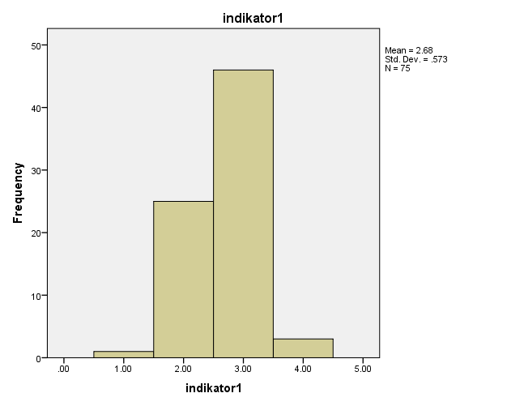
Picture 5.6 the Histogram of Indicator 1
Based on picture 5.6, it can be seen that the highest score is 3, which means that the majority of respondents’ families chose to be the customers of Sharia banks.
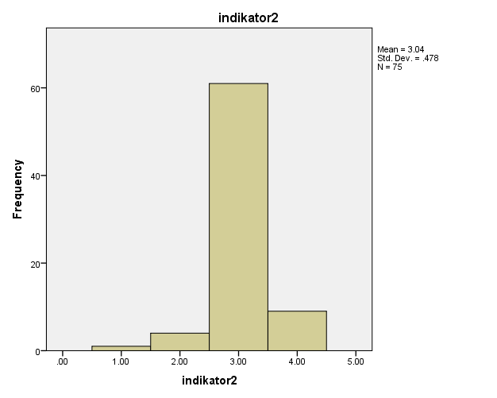
Picture 5.7 the Histogram of Indicator 2
Based on picture 5.7, it can be seen that the highest score is 3, which means that the majority of respondents agree that Sharia bank is anIslamic bank.
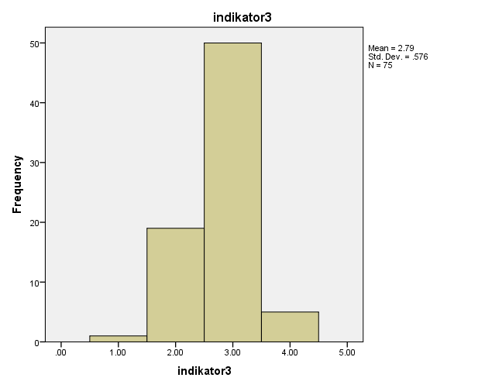
Picture 5.8 the Histogram of Indicator 3
Based on picture 5.8, it can be seen that the highest score is 3, which means that the majority of respondents believe that by using Sharia banks will bring the respondents safe in their worldly life and the hereafter.
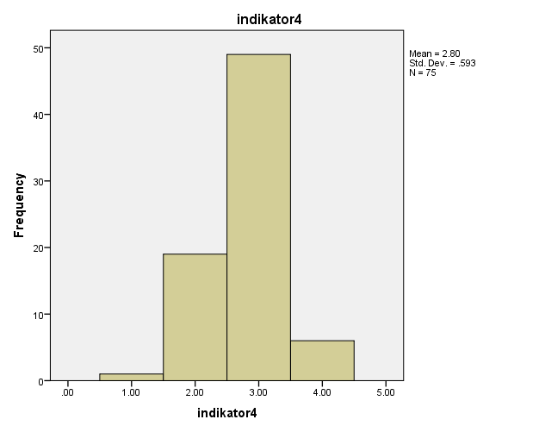
Picture 5.9 the Histogram of Indicator 4
Based on picture 5.9, it can be seen that the highest score is 3, which means that the majority of respondents chose Sharia banks because the MUI’s official religious ruling (fatwa) concerningthe taboo of bank interest.
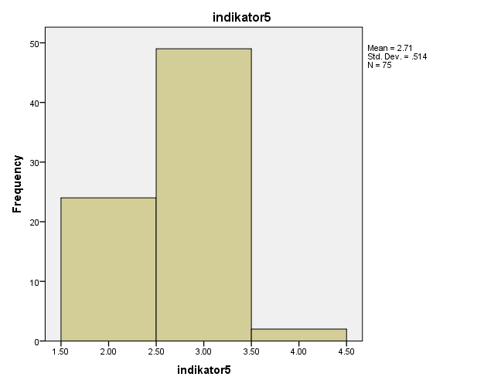
Picture 5.10 the Histogram of Indicator 5
Based on picture 5.10, it can be seen that the highest score is 3, which means that the majority of respondents agree that the Sharia bank is one of banksreceiving a good trustworthiness tierof the society.
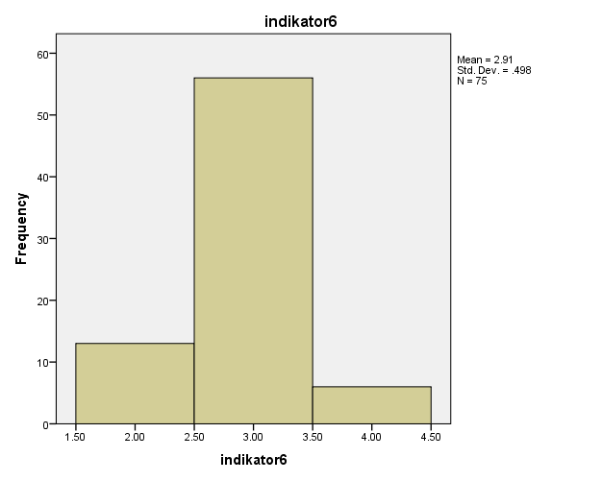
Picture 5.11 the Histogram of indicator 6
Based on picture 5.11, it can be seen that the highest score is 3, which means that the majority of respondents agree that Sharia banks are more profitable and fairer from economy point of view.
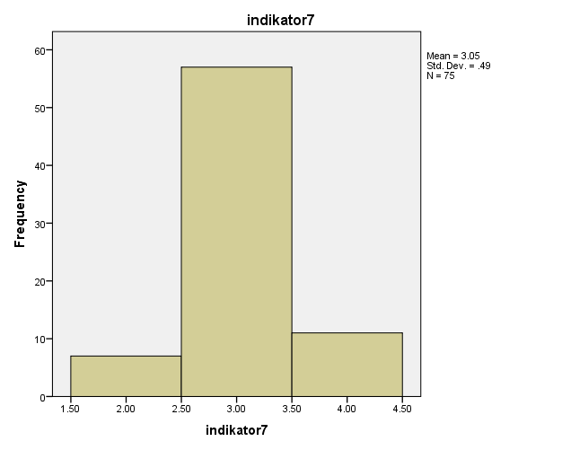
Picture 5.12 the Histogram of indicator 7
Based on picture 5.12, it can be seen that the highest score is 3, which means that the majority of respondents agree that the system of revenue sharing is a universal system which is acceptable because it is beneficial for both the bank and the society.
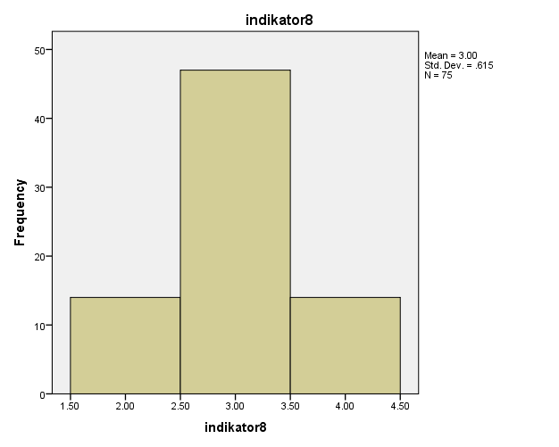
Picture 5.13 the Histogram of indicator 8
Based on picture 5.13, it can be seen that the highest score is 3, which means that the majority of respondents believe that using Sharia banks will positively affect daily activities.

  - THE DESCRIPTION OF PRODUCT UNDERSTANDING VARIABLE
This section describes the results of questionnaires that have been distributed. There are 4 indicators; they are indicator 9 – 12. The answers given by the respondent indirectly reflect respondents' product understanding. The answers of respondents for each indicator on the variable of product understanding can be seen in picture 5.14 up to 5.17.
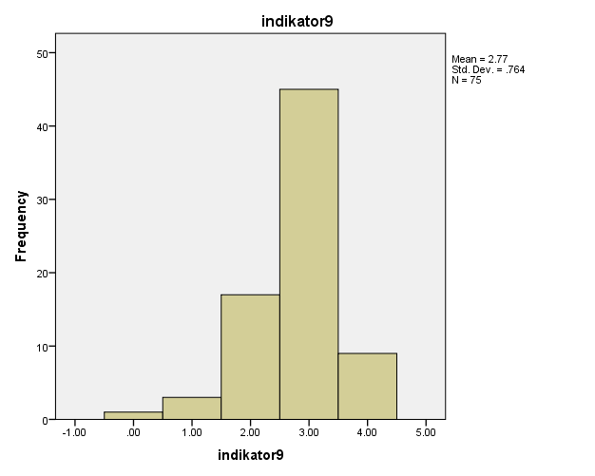
Picture 5.14 the Histogram of indicator 9
Based on picture 5.14, it can be seen that the highest score is 3, which means that most of the respondents knew well the taboo of bank interest (MUI’s fatwa).
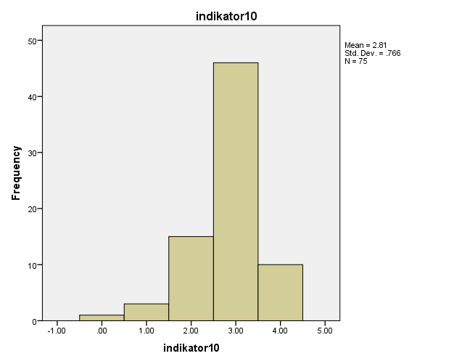
Picture 5.15 the Histogram of indicator 10
Based on picture 5.15, it can be seen that the highest score is 3, which means that the majority of respondents knewwell about Mudlaraba(revenue sharing) principle in Sharia banks.
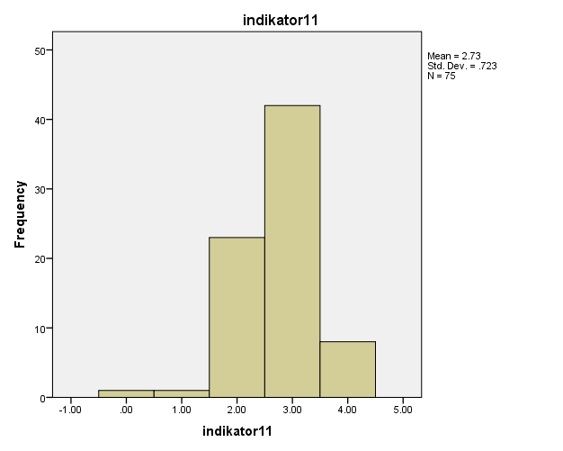
Picture 5.16 the Histogram of indicator 11
Based on picture 5.16, it can be seen that the highest score is 3, which means that most of the respondents knew well about the Musharakaprinciple of Sharia bank.
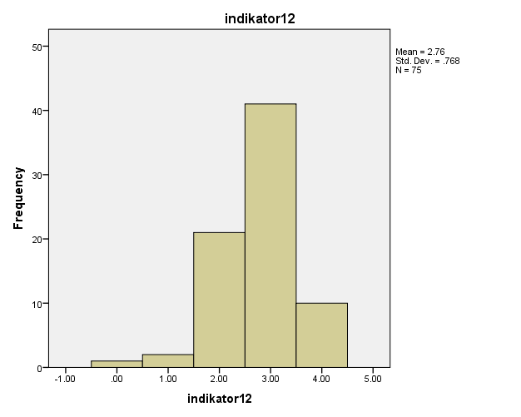
Picture 5.17 the Histogram of Indicator 12
Based on Figure 5.17 it can be seen that the highest score is 3, which means that most of the respondents knew about the Murabahaprinciple of Sharia bank.
IV. DISCUSSION
VARIABLE of PRODUCT UNDERSTANDING
The cognizance of the product asserted in the principles of Sharia banks such as the principle of Mudaraba, Musharaka, and Murabahahave been understood by most respondents. This happened because the respondents work in Islamic environment. The background of respondents working in Islamic environment helps them to have good understanding about the products offered by Sharia banking as its product offer with the principle of Mudaraba, Murabaha and Musharaka which have always been echoed by Sharia banking.
Respondents understand the financialproducts ofSharia banks, in which if the respondent wants to make a deal of financial provision with the Sharia banks side to purchase raw materials or provision of venture capital,under the agreement that the customer will bear the cost for the banks purchase price added with the profit margin at the specified time, thus the respondent can choose Murabaha (deferred payment sale) principle of the Sharia bank financial product.
Respondents knew that to selectSharia banksfinancial productsunderthe agreement that the bank will provide the capital and the respondent as the customer acts as the manager of the fund, in which the gain or loss arising from the management of these funds will be paid by both parties with different amount of the partitionfitting to the agreement at the beginning. If so, the respondent can choose Mudharabah (Trust financing/ Investment Trust) principle of the Sharia bank financial product.
Respondents also knew well about Musharaka (patnership, Project Financing Participation) principle of Sharia bank financialproducts, where the respondents concluded that the financial products based on the principle of Musharaka is an agreement or financing agreements where the Sharia banks and customers together finance a business and managed jointly on the principle of sharing profits in which the benefits and losses will be divided fitting to the first agreement.

VARIABLE OF EDUCATION
Based on picture 5.3 of the respondents’ characteristics based on their education level show that 5% or 4 respondents have the highest education level as an undergraduate (S1), 83% or 63 respondents took magister level/ S2, 12% or 9 respondents are indoctoral level/ S3 and there are no respondents whosetheir last educationdiploma 3/ D3.
The majority of respondents education whichhas reached stratum 2 level (S2) shows that respondents have been able to analyze and chooseSharia banks as partners to store their funds. By having higher education, the respondents would not choose the Sharia banks carelessly to make savings on their funds ownership, especially just to follow the trend of savings in Sharia banks.
Having higher education levelsupported with Islamic background encourages respondents to seriously choose Islamic banks, this was due to a strong understanding of interest prohibition in Muslim’s management of funds. Where the respondents know that all conventional banks implemented an interest system in the management of customer funds. And usury is a sinful action to do, so the respondents whose their education reached magister level would avoid to make savings in conventional banks and prefer Sharia banks.
VARIABLE of CULTURE
The cultural environment of STAIN Ponorogo and the Faculty of Islamic Studies Ponorogo is in Islam atmosphere which believes Islamic Sharia as a principle in the lives of the respondents. The respondents’ reasons choosing financial services are as follows:
NO. | REASON OF CHOOSING | AMOUNT | PERCENTAGE
1. | Knowing Islamic law | 19 | 25 %
2. | The rules of the institution where they work at | 27 | 36 %
3. | Invited by their husband / wife, family, relatives, friends | 2 | 3.4 %
 | More favorable for investment and financial transactions | 22 | 29 %
4. | ETC:  Easy to find (conventional)  The procedure is easy (conventional)  Too late to change (conventional)  Try out (Sharia) | 5 | 6.6 %
 | AMOUNT | 75 | 100 %
Source: processed primary data
Islamic working environment do encourage respondents to use the services of Islamic financial institutions. Respondents of this study concluded that apart from the factor of education and understanding of Islamic bank financing products, there are other factors which play an important role encouraging the respondent to use the Shariabank's products. It is the policy of the institution where the respondent worked, where institutional cooperatewithSharia banks in the salaries distribution, so as to encourage the respondents to open account of suchSharia banks.
VARIABLE of PERCEPTION
Based on the description of the variables above, the perception of both STAIN Ponorogo and Islamic Studies Faculty Ponorogo’s lecturerstoward the Sharia bank is good. It can be seen from the behavior of the consumer / respondents’ behavior which were influenced by the factor level of education in which largely is dominated by a magister level/ S2, the factor of culture through Islamic culture in the work environment of both STAIN and UNMUH Ponorogo, as well as the stimulus from theirSharia products understanding that generate a good perception as the feedback of the stimulus.
Perception which will be expressed by respondents after receiving stimulation before doing purchasing behavior is to decidewhether or not to use Sharia financial services. Financial transactions carried out by most respondents, or 63% of respondents use the services of conventional banks and Sharia banks, while those who only use pureSharia financial services are just 11 respondents from the entire number of respondents. This has become a new phenomenon found in this study and the respondents use the services of conventional and Sharia banks are based on the rules of the institution where they work.
Respondents still think the profitability of choosing a bank for theirfunds storage and the use of bank financing products. This is what causes the majority of respondents do not have a strong loyalty in choosing a bank. Respondents still considers it necessary and important to have an account or dofinancing transactions by using the services of conventional banks due to high interest rates which is a very lucrative opportunity for savings in conventional banks.Meanwhile to use the products of Islamic bank in fund borrowing is very profitable because the customersdo not have to bear all the losses experienced. There were few respondents who actually have a high loyalty to the Sharia bank products but the policy of their institutions partnered with the conventional banks demands the respondents to open bank accounts and use conventional bank products.

CONCLUSIONS AND RECOMMENDATIONS
5.1. CONCLUSION
1. the perception of both STAIN Ponorogo and Islamic Studies Faculty Ponorogo’s lecturers toward the Sharia bank is good.It can be seen from the behavior of the consumer / respondents’ behavior which were influenced by the factor level of education in which largely is dominated by a magister level/ S2, the factor of culture through Islamic culture in the work environment of both STAIN and UNMUH Ponorogo, as well as the stimulus from their Sharia products understanding that generate a good perception as the feedback of the stimulus. Perception which will be expressed by respondents after receiving stimulation before doing purchasing behavior is to decide whether or not to use Sharia financial services.
2. Financial transactions carried out by most respondents, or 63% of respondents use the services of conventional banks and Sharia banks, while those who only use pure Sharia financial services are just 11 respondents from the entire number of respondents. This has become a new phenomenon found in this study and the respondents use the services of conventional and Sharia banks are based on the rules of the institution where they work.
5.2. SUGGESTION
1. It is a must for Sharia bank to better cooperation with the agencies in its marketing strategy so that the mission and vision of Sharia can be conveyed to the public through the institution where they work.
2. Sharia banks should improve the socialization of Sharia to all institutions or group/ society organization in Ponorogo, so that people will feel more familiar with the Sharia principles in the management of Sharia banking.
BIBLIOGRAPHY
Arikunto, Suharsimi, 2002, Procedure of Research, Rineka Cipta, Jakarta
Abu Muhammad Dwiono K.A, 2012, Goodbye, Conventional Bank, Tifa CV Surya Indonesia, Jakarta.
Antonio M. Syafi`i. 2001. Sharia Banking: From Theory to Practice. Jakarta: Gema Insani Press
Bank Indonesia, 2015, Islamic Banking Statistics. May 2015
Bank Indonesia Circular Letter No. 15/7 / DPNP on March 8, 2013 about the opening of Bank Office Network.
Burhan Bungin, Prof., Dr., S. Sos. M.Si 2005, Quantitative Research Methodology, Publisher Prenada Media, Jakarta.
Blueprint of Islamic Banking Development in Indonesia, 2002
Chapra, M. Umer. 2000. Islamic Monetary System. Translated by Ikhwan Abidin B. Jakarta: Gema Insani Press.
Dahlan Siamat, 2004, The Management of the Financial institution;Fourth Edition, Faculty of Economics, University of Indonesia, Jakarta.
Gudono. 2012. Multivariate Analysis. Yogyakarta: BPFE
Indriantoro, Nur and Bambang Supomo, 2002 Business Research Methodology For Accounting and Management, First Edition, BPFE Yogyakarta.
Karim, Adiwarman. 2004. Islam Bank: Fiqh and Financial Analysis. Jakarta: King Grafindo Persada.
Kotler, Philip, 2009, Marketing Management, Volume 1, Issue 13, Erlangga, Jakarta
Lewis, Mervyn K. and Latifa M. Algaoud. 2005. Sharia Banking: Principles, Practices and Prospects.Translated by Burhan Wirasubrata. Jakarta: Serambi Ilmu Semesta.
Shinta Agustina 2011, Marketing Management, Brawijaya University Press, Malang
Sugiyono. 2008. Quantitative Research Methods, Qualitative and R & D. Bandung: Alfabeta.
Sumitro, Warkum. 2004. Principles of Islamic Banking and Related Institutions(Bamui, Takaful and Islamic Capital Market) in Indonesia. Jakarta: Raja Grafindo Persada.
Toni Prasetyo Utomo, 2014, Analysis of Factors Affecting Customer Decision In Choosing Islamic Banking Services, Thesis, University of Brawijaya.

